Assignment 02

Step 1 : use this solidity code for   
  
// SPDX-License-Identifier: MIT

pragma solidity ^0.8.0;

import "hardhat/console.sol";

contract WavePortal {

uint256 totalWaves;

event NewWave(address indexed from, uint256 timestamp, string message);

function wave(string memory _message) public {

totalWaves += 1;

console.log("%s has waved w/ message %s", msg.sender, _message);

emit NewWave(msg.sender, block.timestamp, _message);

}

function getTotalWaves() public view returns (uint256) {

console.log("We have %d total waves!", totalWaves);

return totalWaves;

}

}

Step 2 : compile it and see the green tick

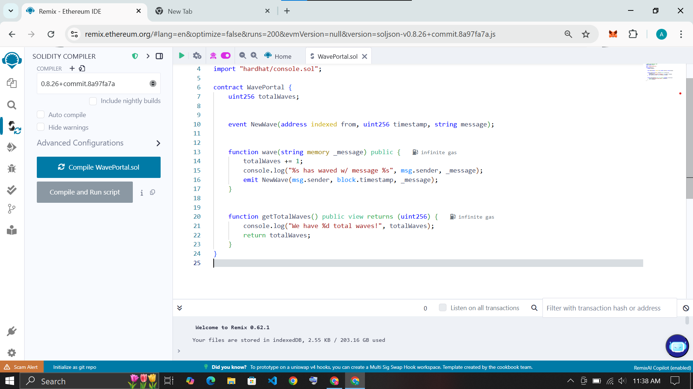

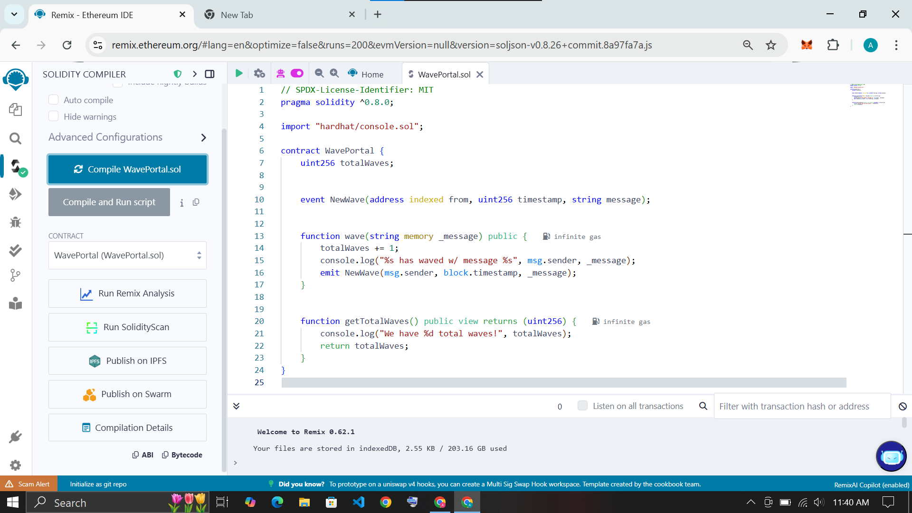

Step 3: navigate to Deploy and Run transaction section in left sidebar select Environment as [‘Injected provider - MetaMask’] and confirm the request

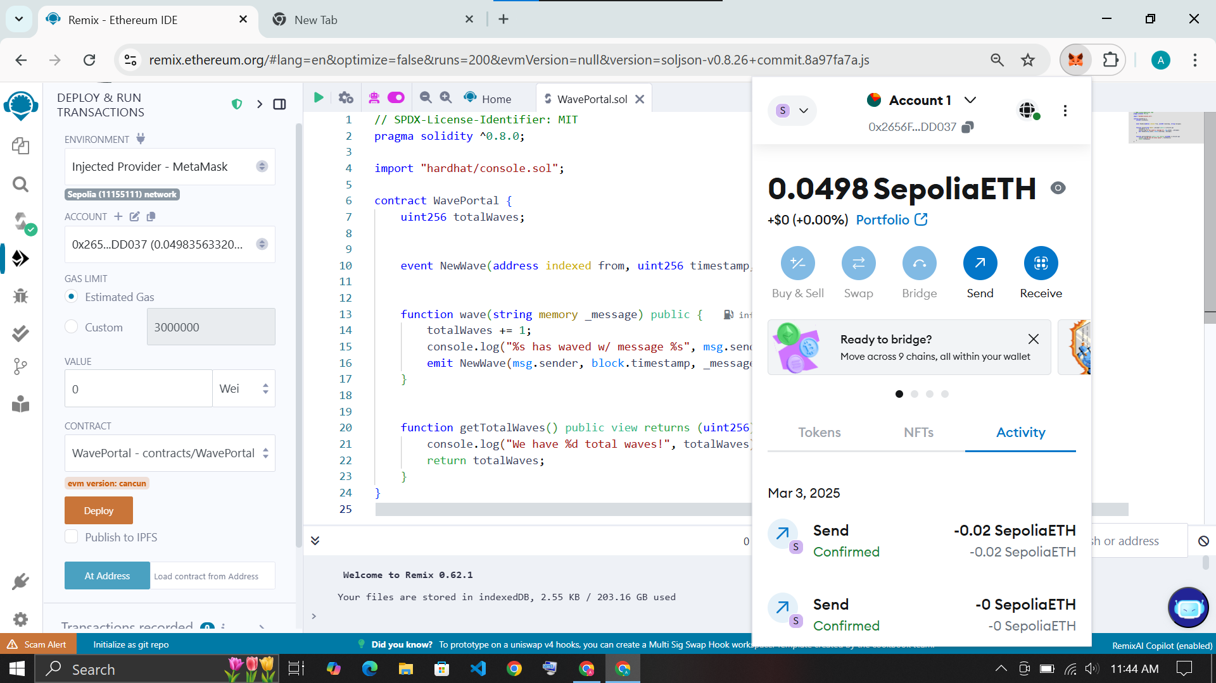

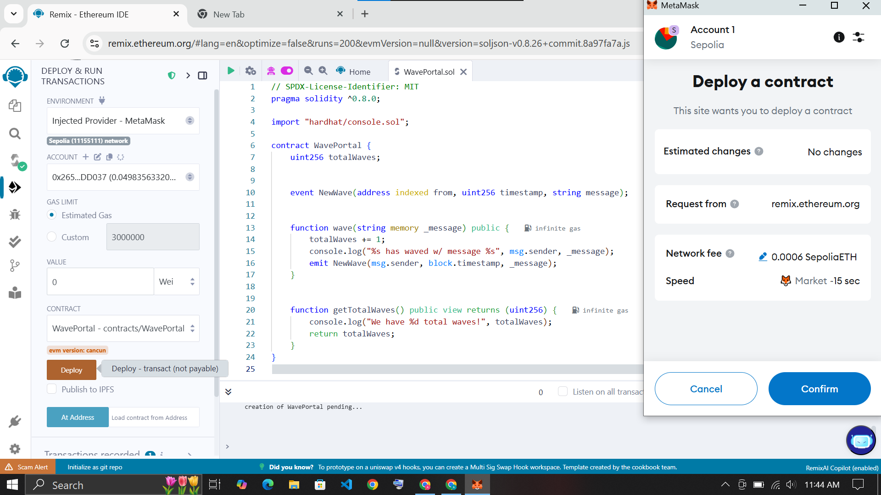

After confirming the request see the confirm transaction pop up.

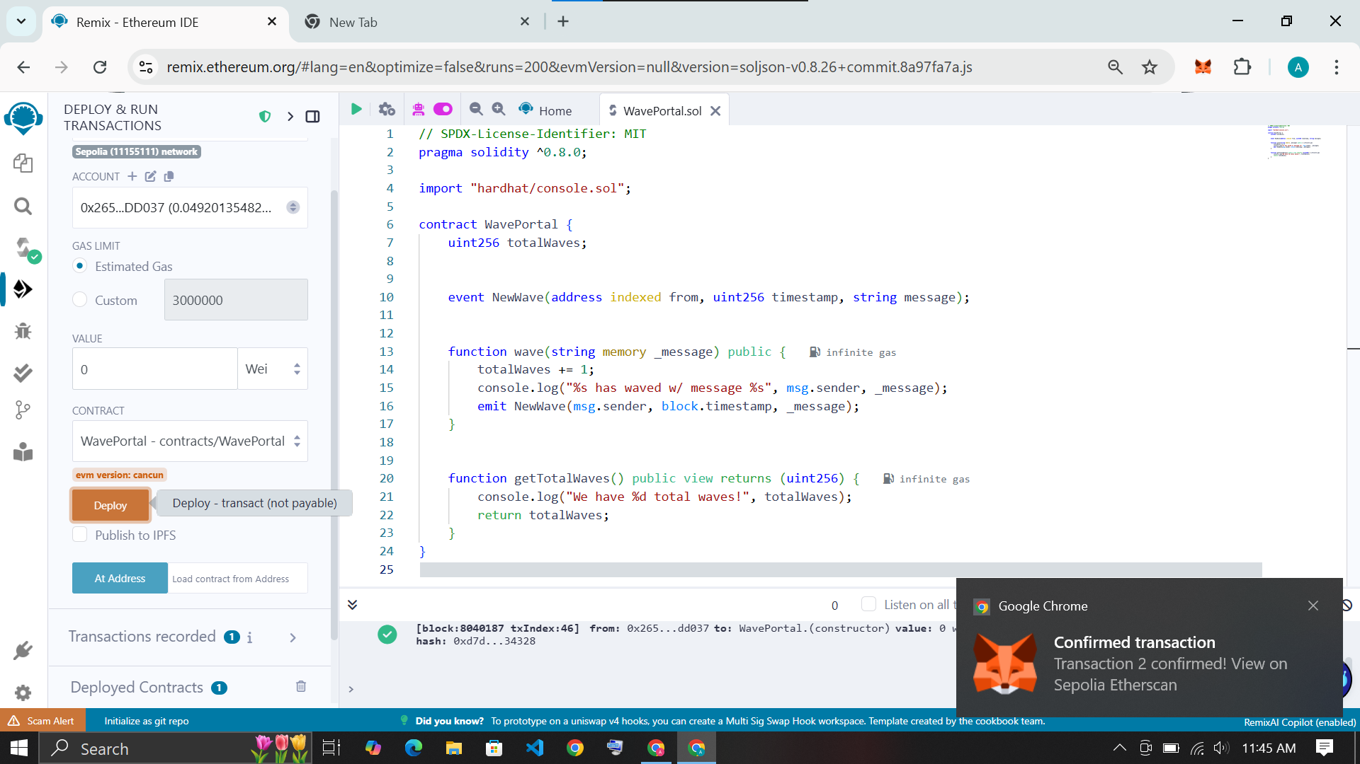

In terminal see the transaction log on [‘Etherscan’] or [‘Blockscout’]  
  
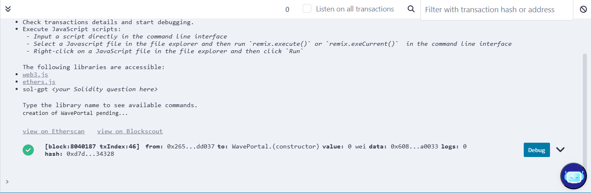

Enter a string value in left side deploy contract input ‘BIA44 AmanMujawar’ and click on wave and confirm transaction request.

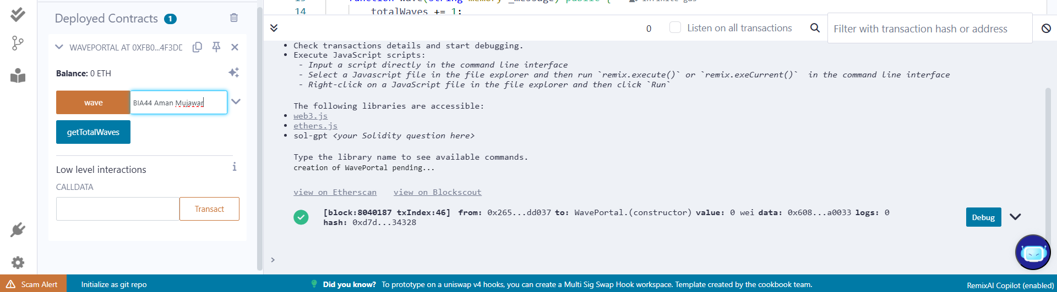

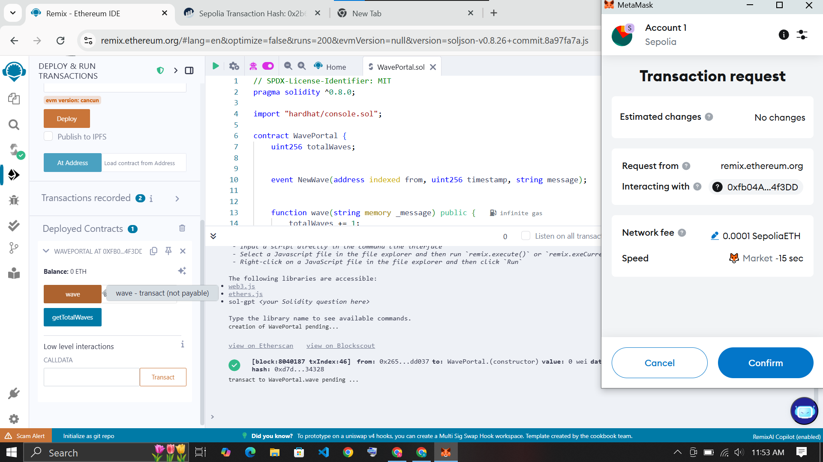

See the confirmation message of transaction

On click ‘Blockscout’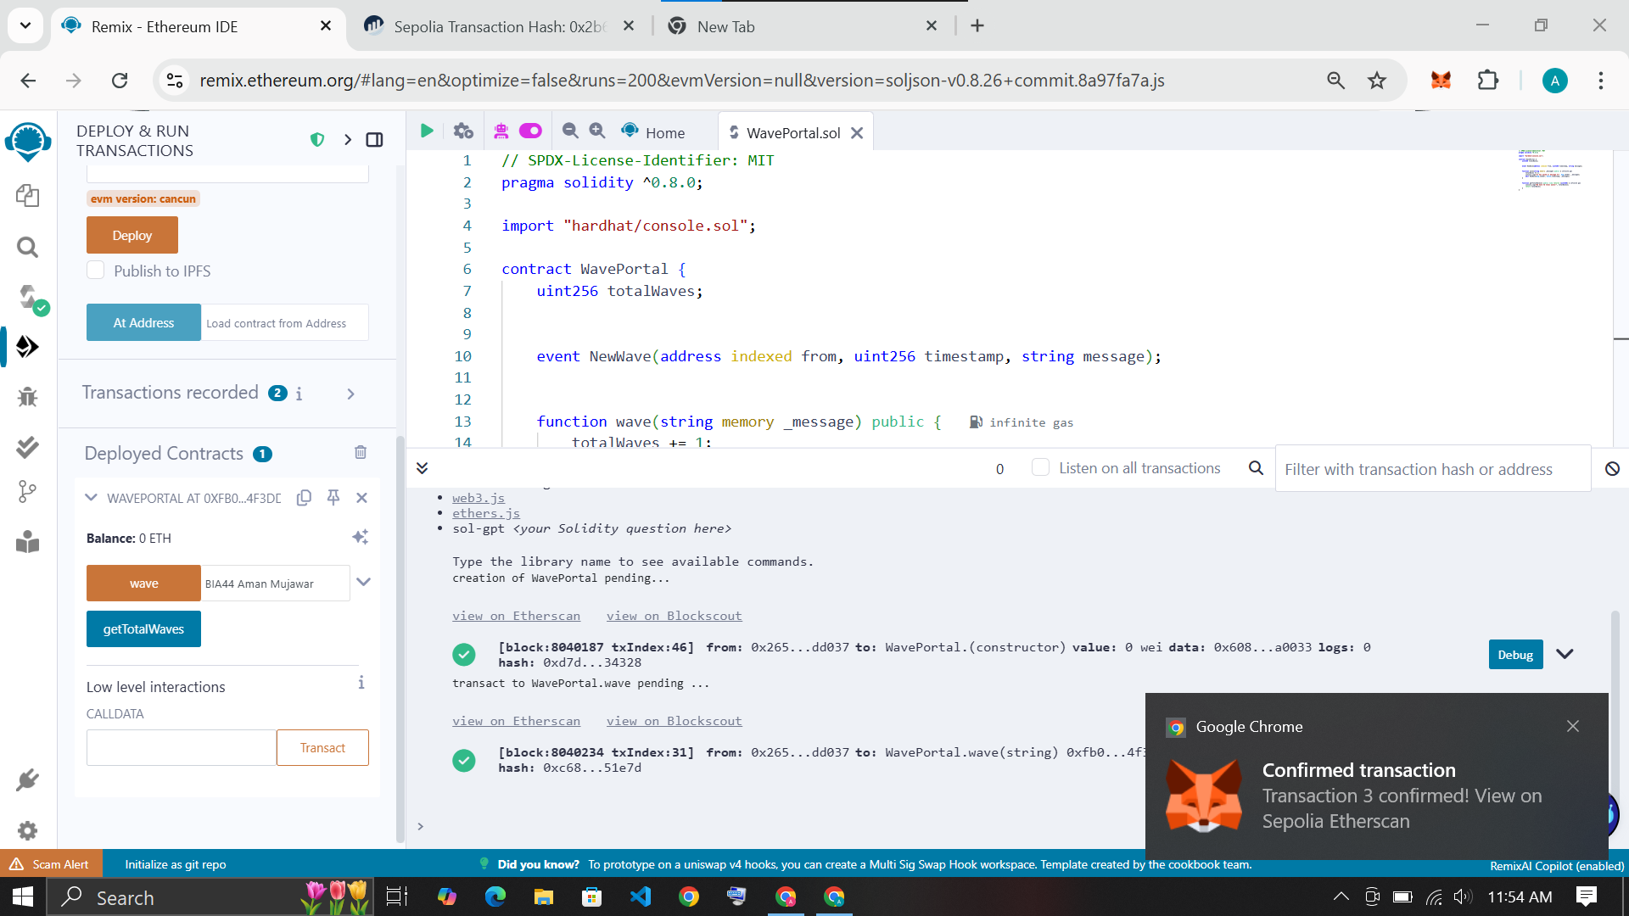

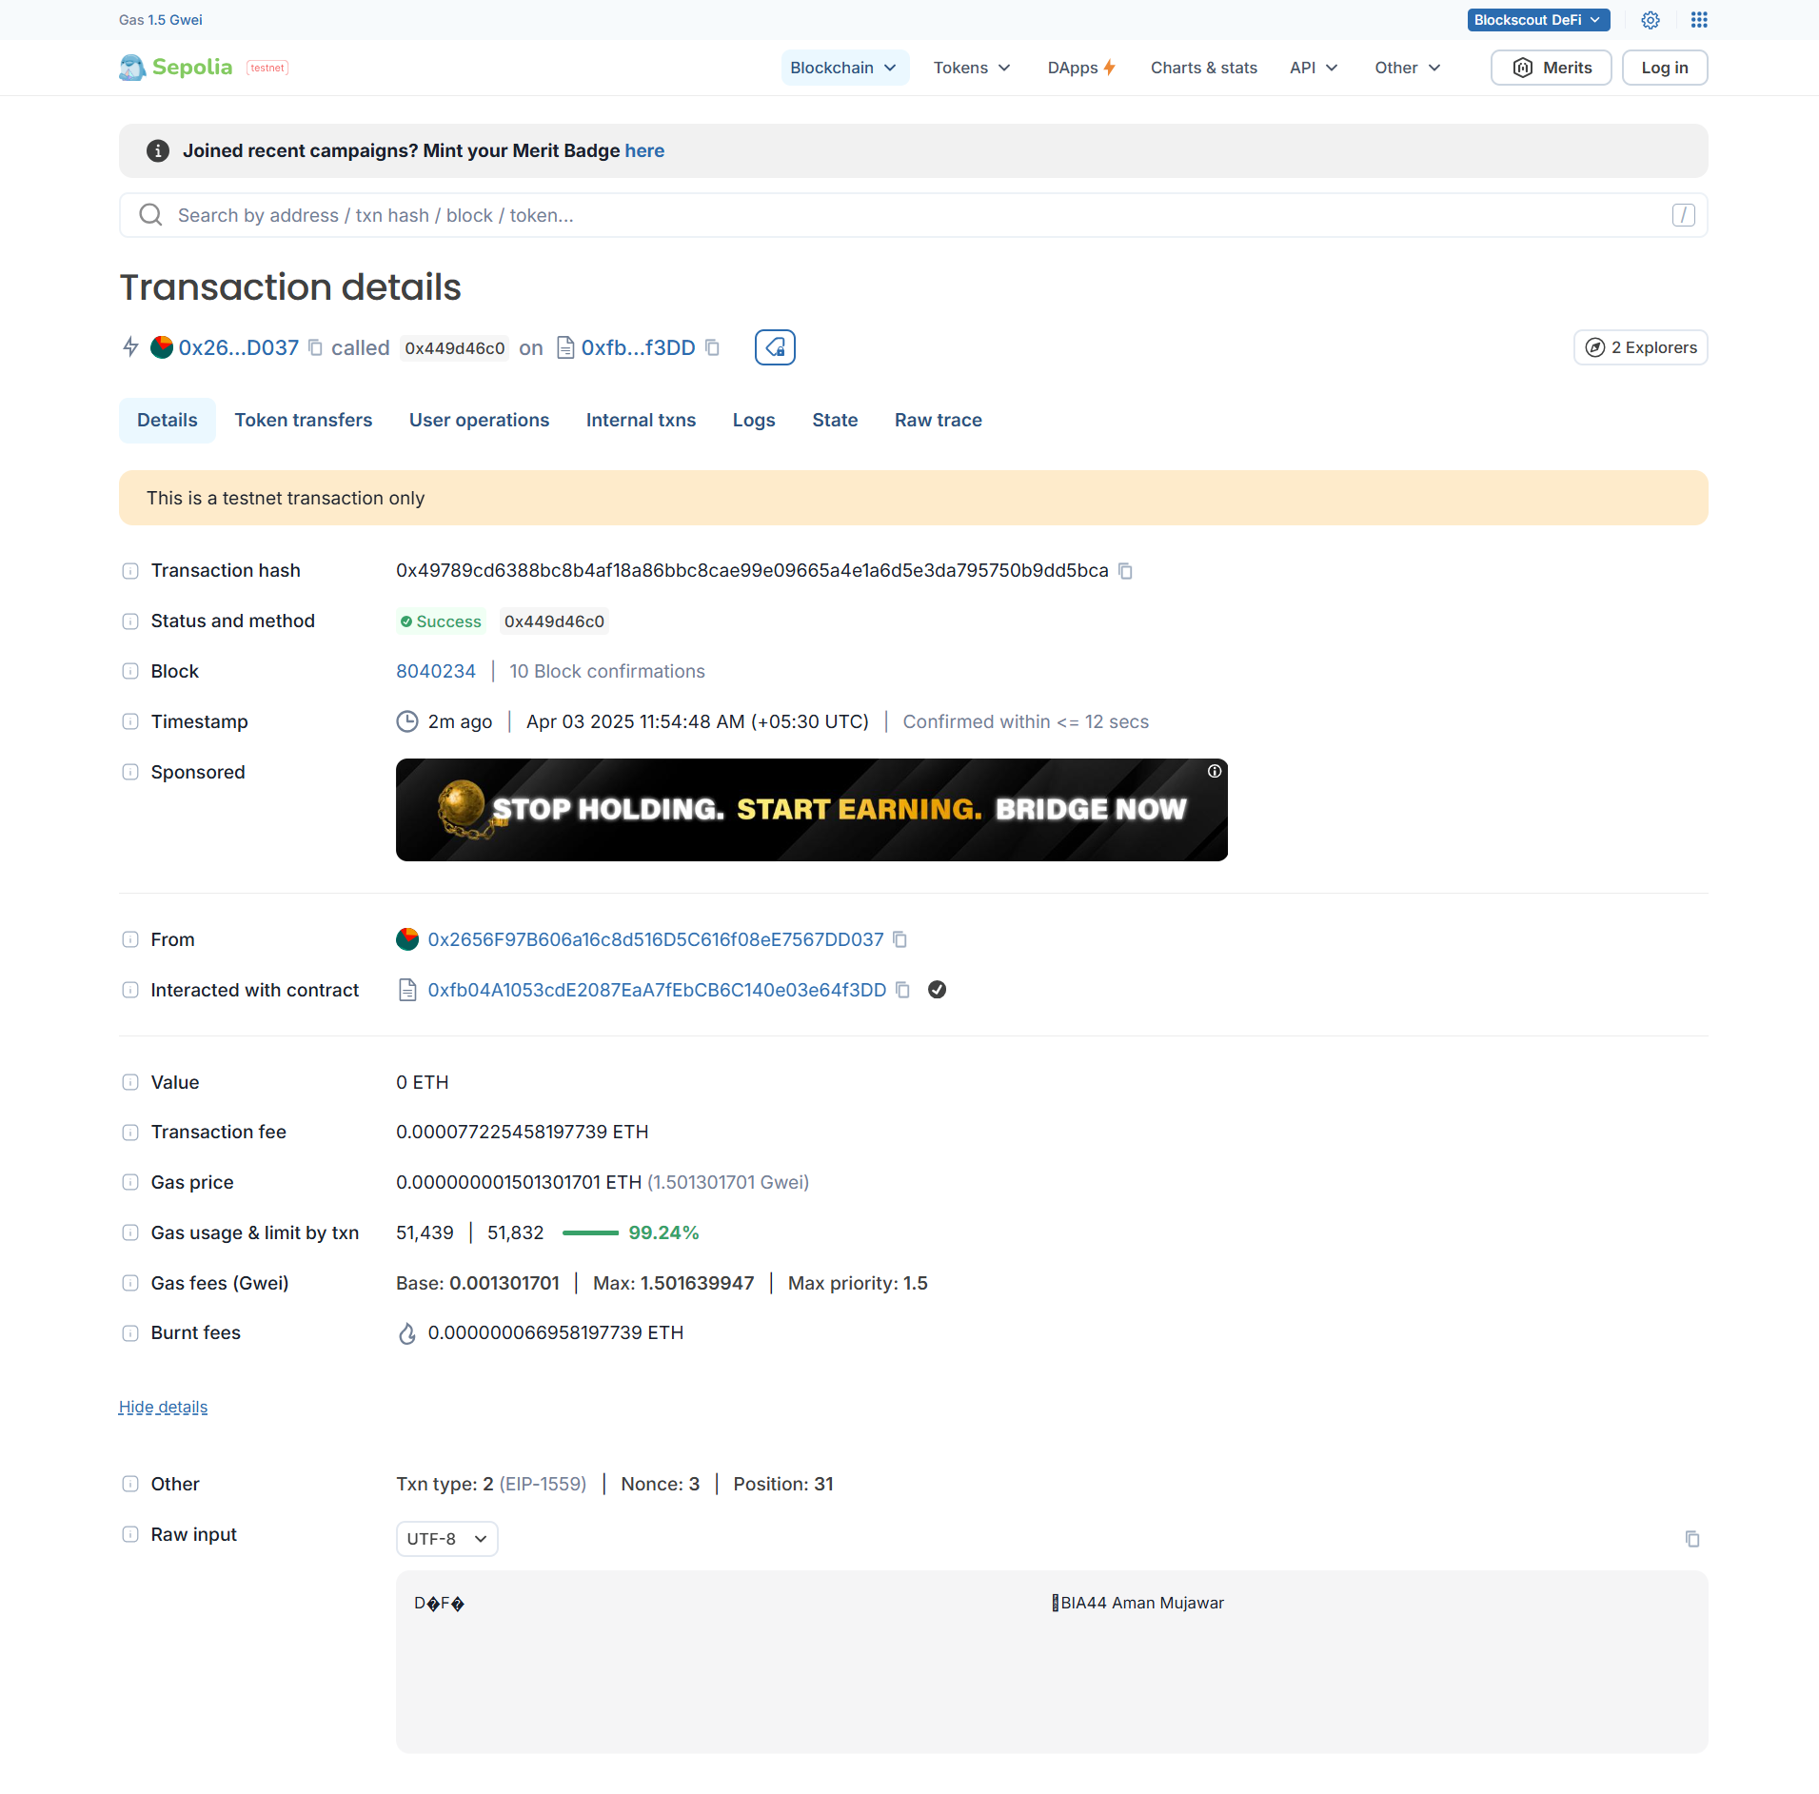

On click Etherscan see the data is showing ‘BIA44 Aman Mujawar’

